Dear _____________________,
____________________________ invites you to visit our stand №____ , pavilion №____ at Expocentre Fairgrounds (Moscow), the 20-th international exhibition of the chemical industry and science "Khimia-2017", which will take place in October 23 - 26, 2017.

Exhibition sections:
Get a personal e-ticket
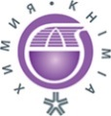 | Chemistry. Petrochemistry  Raw materials, auxiliaries, semi-finished products and finished products for chemical and petrochemical sector and other applications.
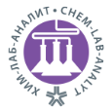 | Chem-Lab-Analyt  Analytical and Laboratory Equipment. Laboratory Furniture and Glassware. Chemical Reagents.
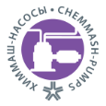 | ChemMash. Pumps  Chemical Engineering and Pumps. Machines, equipment and instruments.
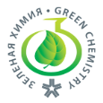 | Green Chemistry  Industrial biotechnologies, water treatment and water purification, chemical safety.
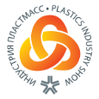 | Plastic Industry Show  Raw Materials and Equipment for Production and Processing of Polymers and Plastics.
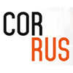 | CORRUS  International Salon of Equipment and Technologies for Corrosion Protection and Corrosion Resistant Materials.
Innovation and Advanced Materials
Research and development.
Startup Chemzone
Startups and SMEs.
Service
Engineering and automation, IT software, logistics and storage, packaging, consulting and others.

Please, fill in a registration form, specify a promo code Chemistry2417 and print out your e-ticket for an exhibition visit.

Exhibition time:
From 23 till 25 October 2017
from 10:00 till 18:00
26 October 2017
from 10:00 till 16:00

The place of Exhibition:
Expocentre, Moscow, Krasnopresnenskaya nab., 14

Access:
To the metro station "Vystavochnaya" / "Delovoy tsentr".
More details about transportation and parking >>>

More information
about this exhibition and business programme:
www.chemistry-expo.ru/en/

Organizer – Expocentre AO
With support of Russian Ministry of Industry and Trade, Russian union of chemists, ОАО NIITEKHIM, Mendeleev Russian Chemical Society, Dmitry Mendeleev University of Chemical Technology of Russia.
Under auspices Russian Chamber of Commerce and Industry.

